

Lab exam
Cloud Computing
Name: Saira Ejaz
Reg no: 2023-BSE-057(5-B)
Task no 1:
Repo Link: https://github.com/23-22411-057-sudo/Lab_exam

Q1 – AWS IAM Setup Using AWS CLI and Console Verification (10 marks)
q1_create_group.png
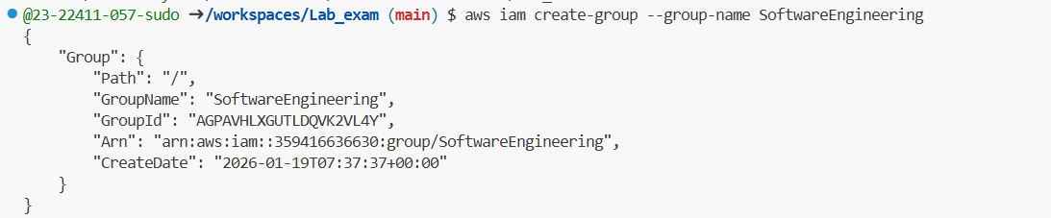
q1_group_details.png
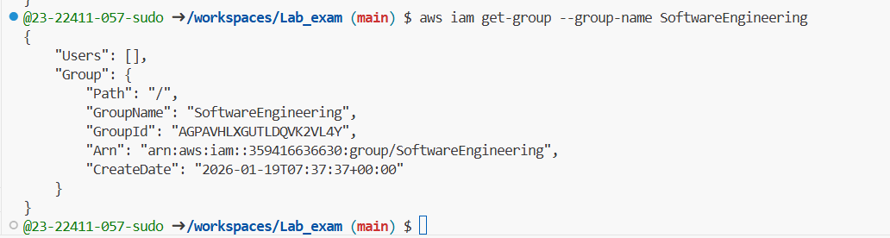
q1_create_user.png
q1_user_details.png
q1_add_user_to_group.png (three ss in same picture)
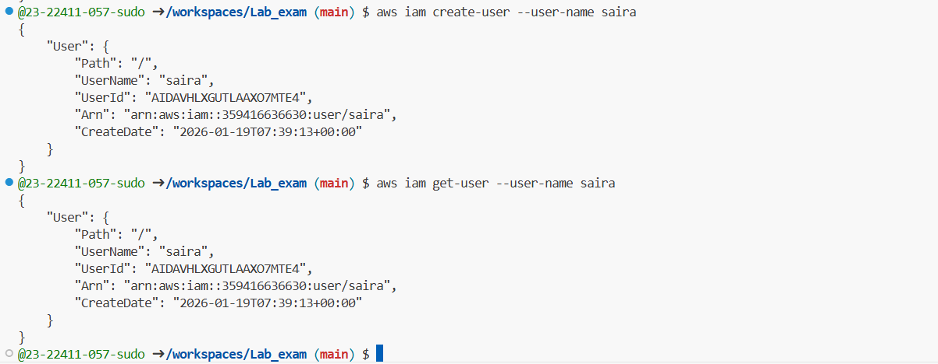
q1_group_membership.png
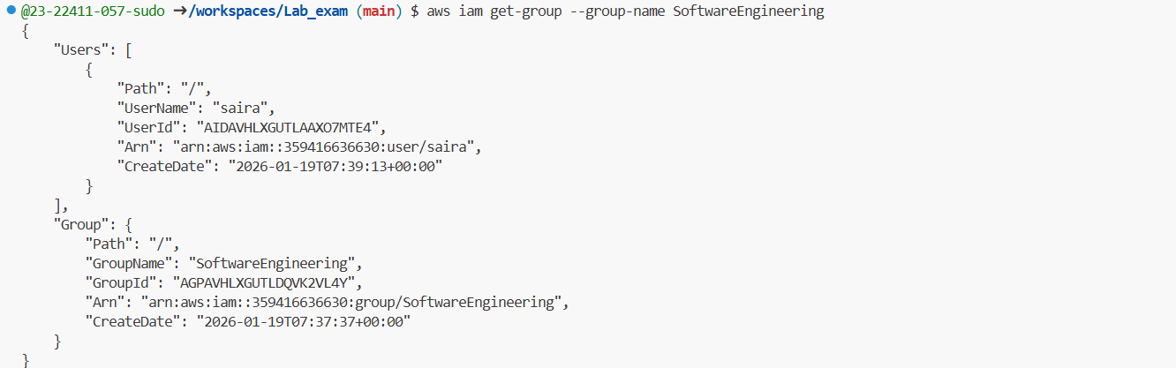
q1_find_admin_policy.png
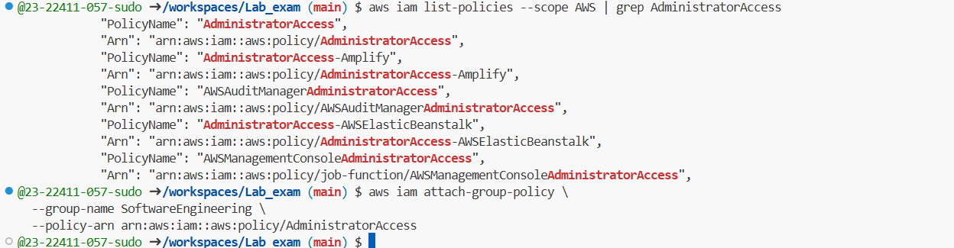
q1_attach_admin_policy.png
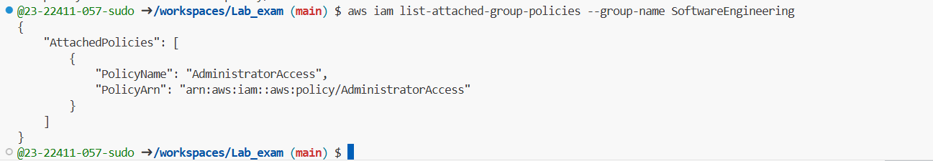
All console screeshots:
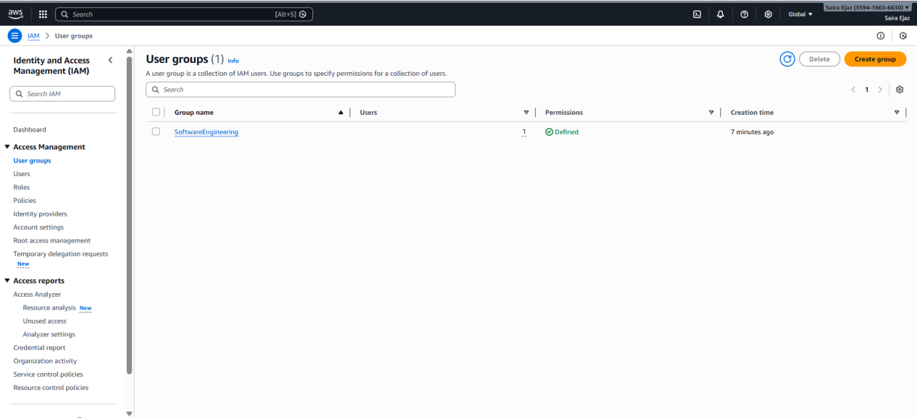
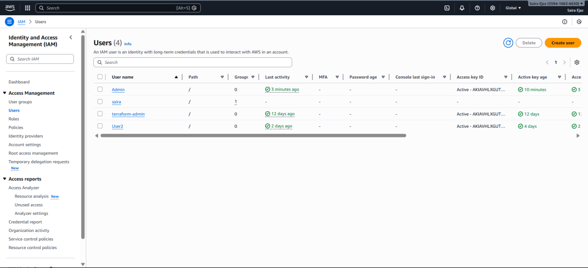
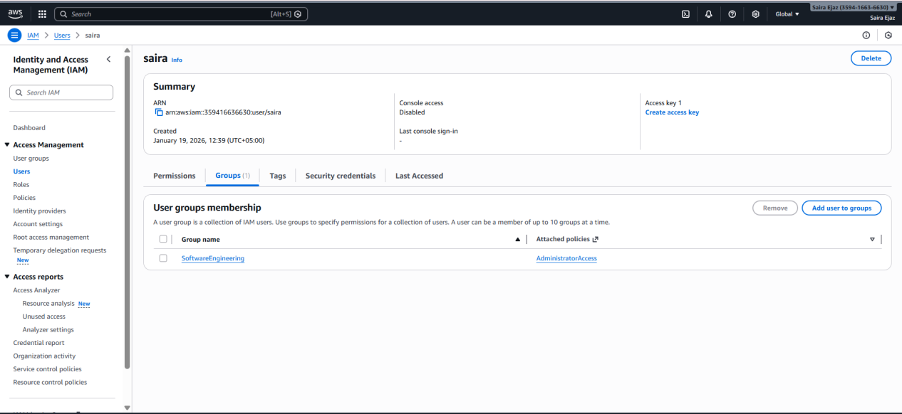

Q2 – Terraform Lab: Simple AWS Environment with Nginx over HTTPS (30 marks)

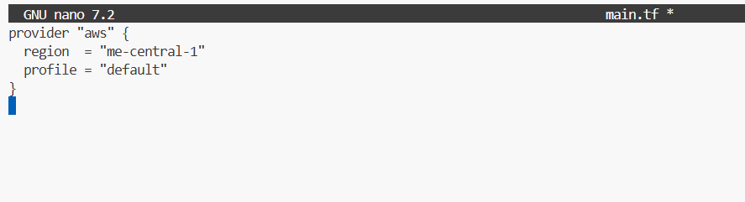
- q1_group_details.png
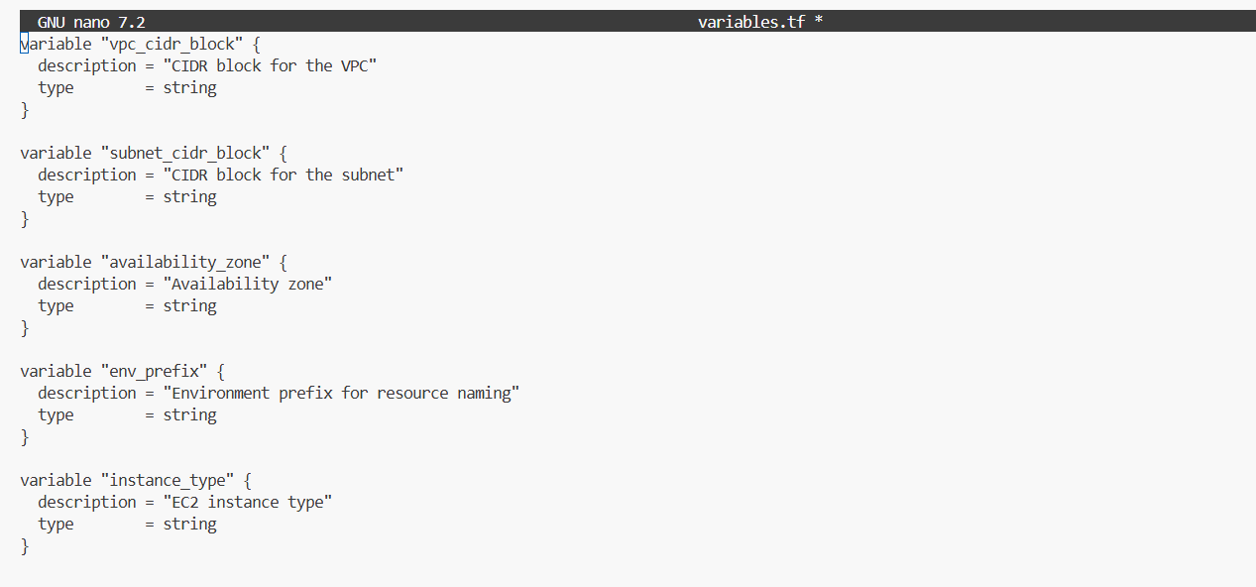
- q2_vpc_subnet.png
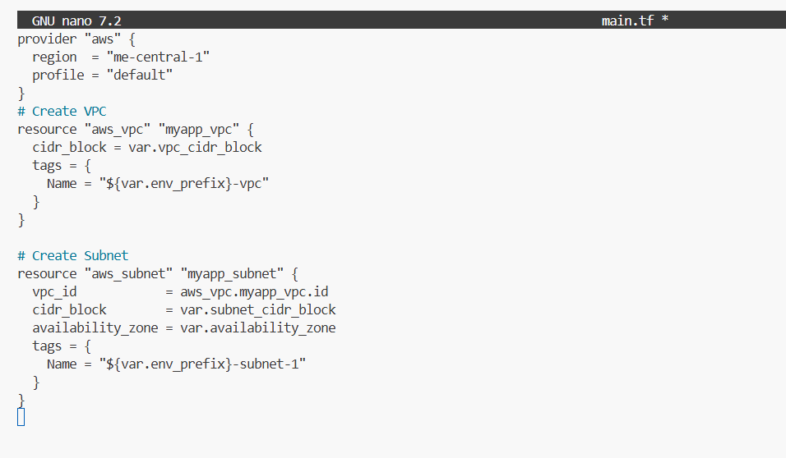
- q2_igw_route_table.png
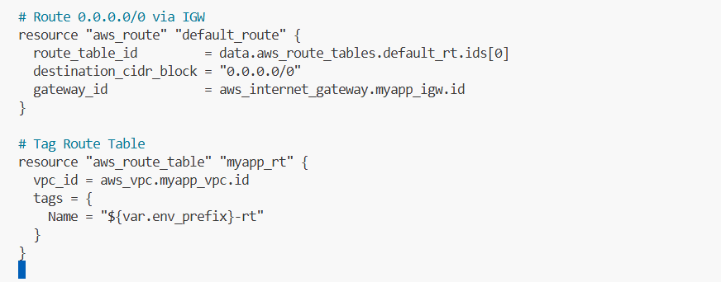
q2_http_and_locals.png
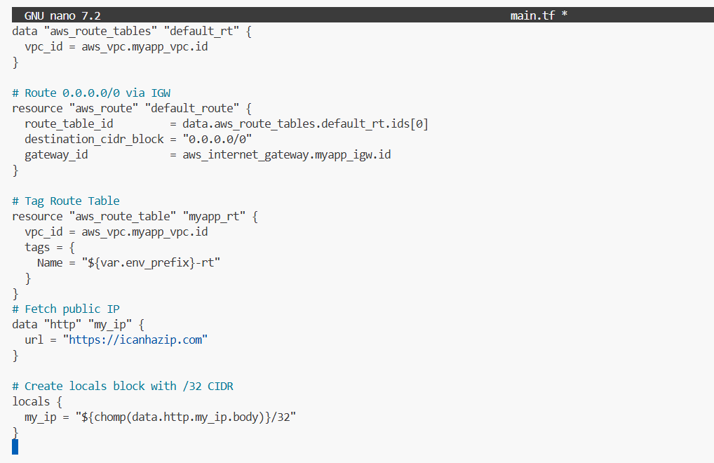
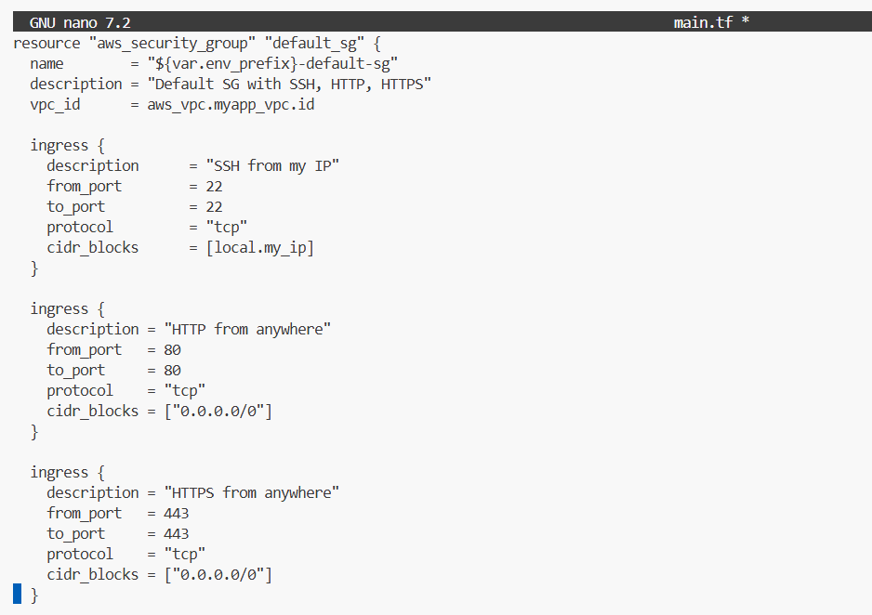
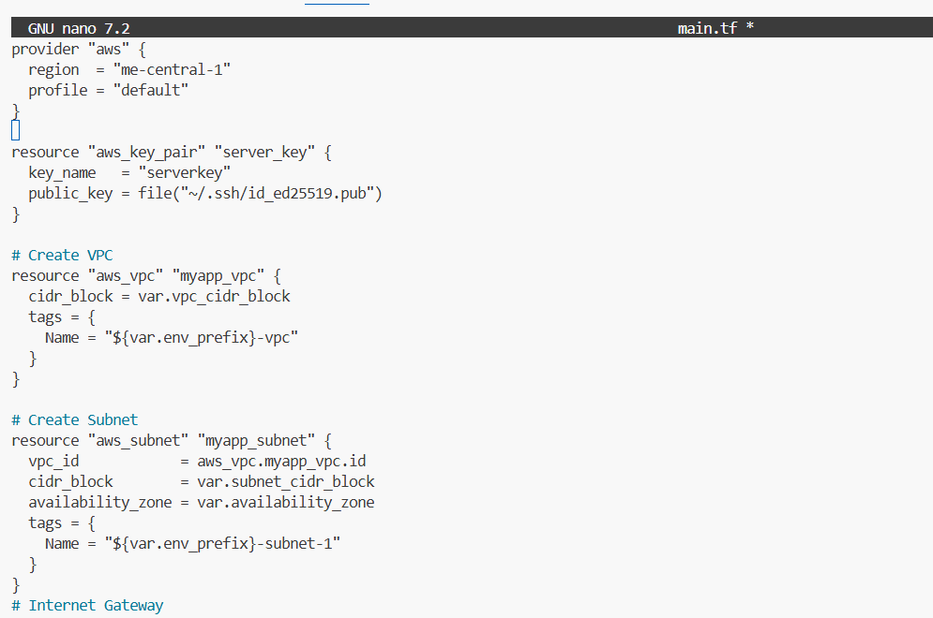
q2_ec2_resource.png
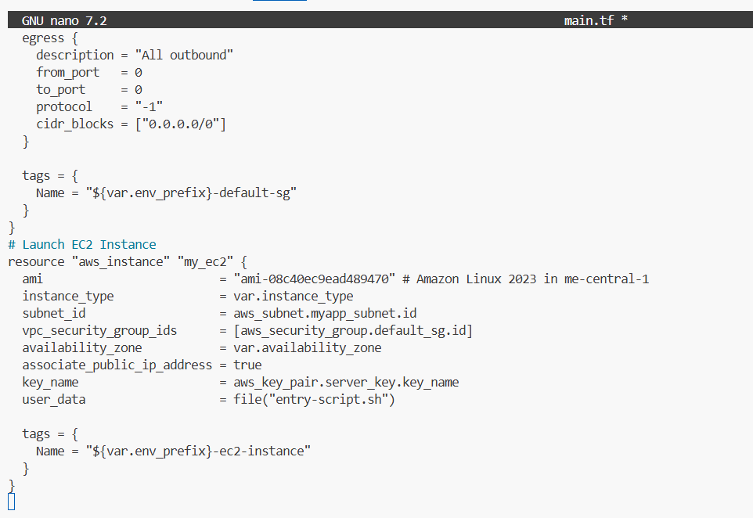
q2_entry_script.png
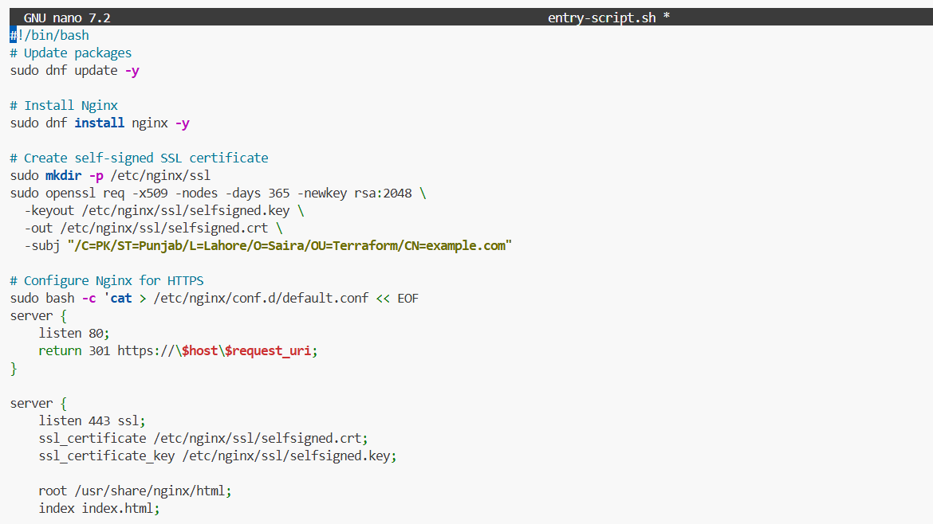
q2_output_block.png
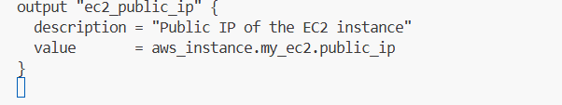
q2_tfvars_or_vars.png
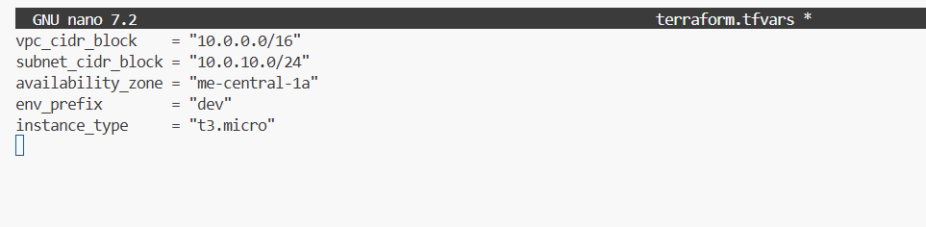
q2_terraform_init.png
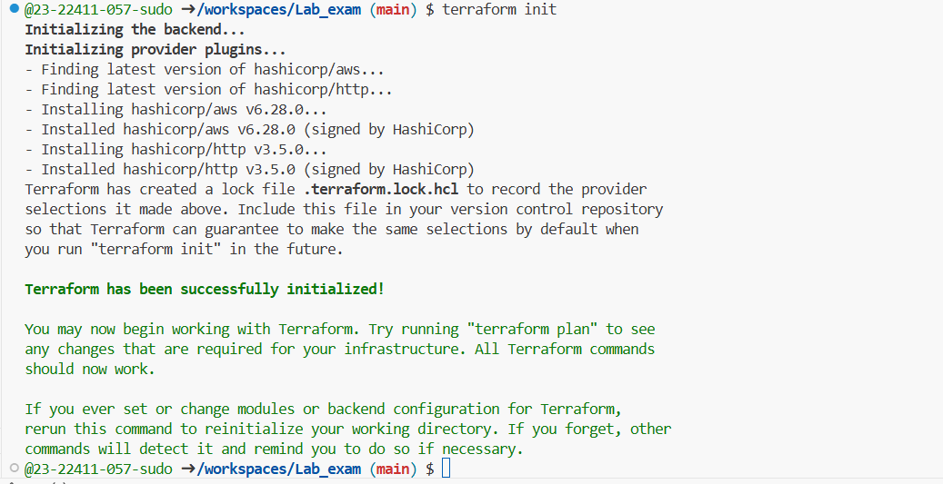
q2_terraform_plan.png
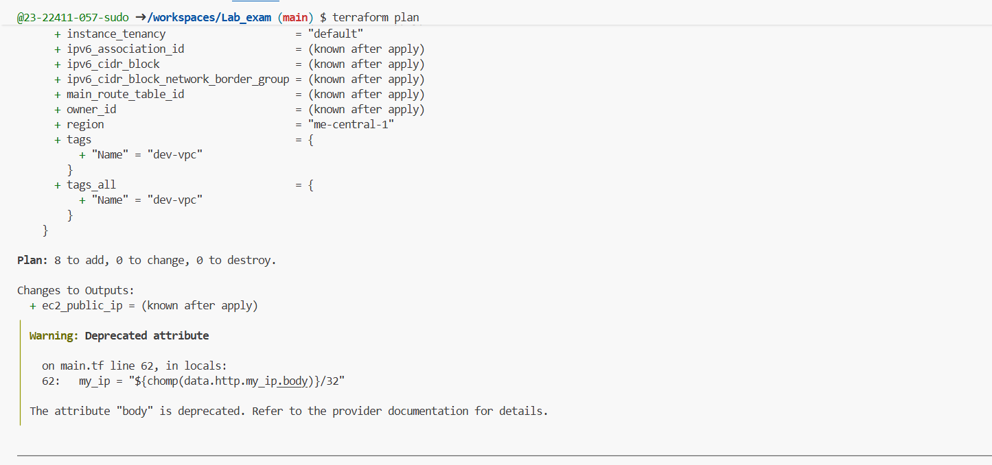
q2_terraform_apply.png
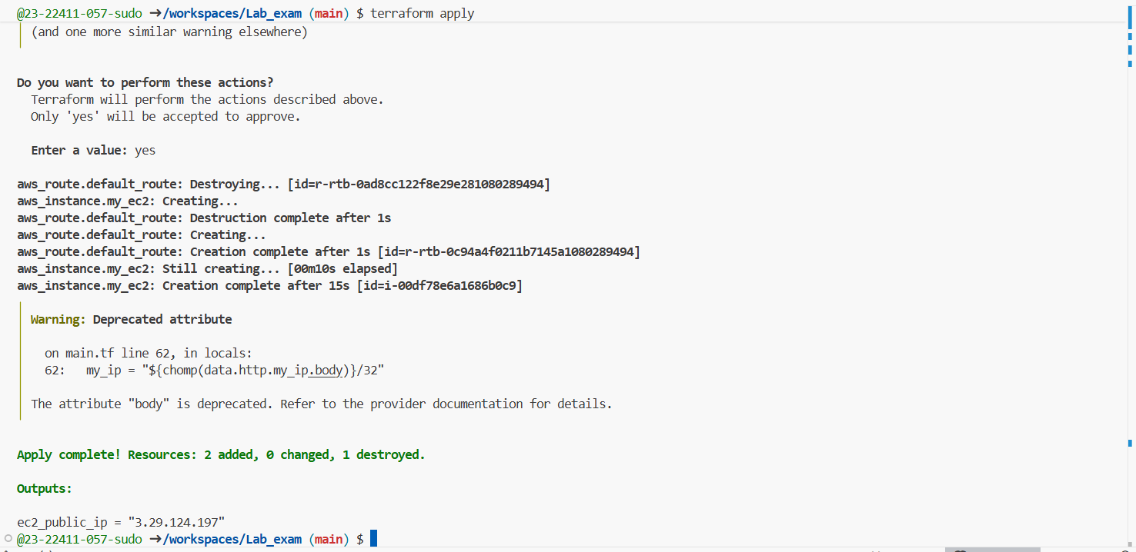
q2_console_vpc.png
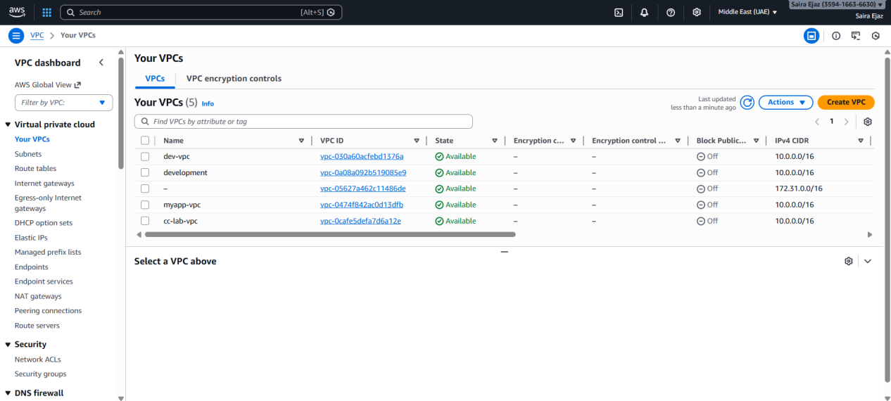
q2_console_subnet.png
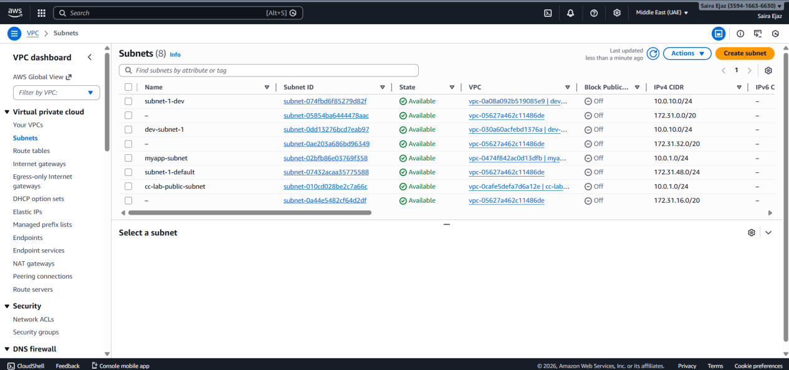
q2_console_igw.png
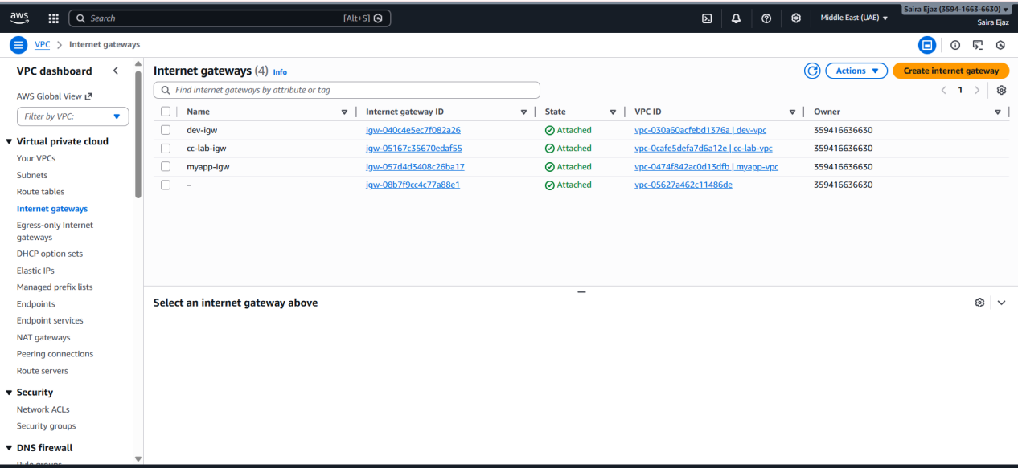
q2_console_route_table.png
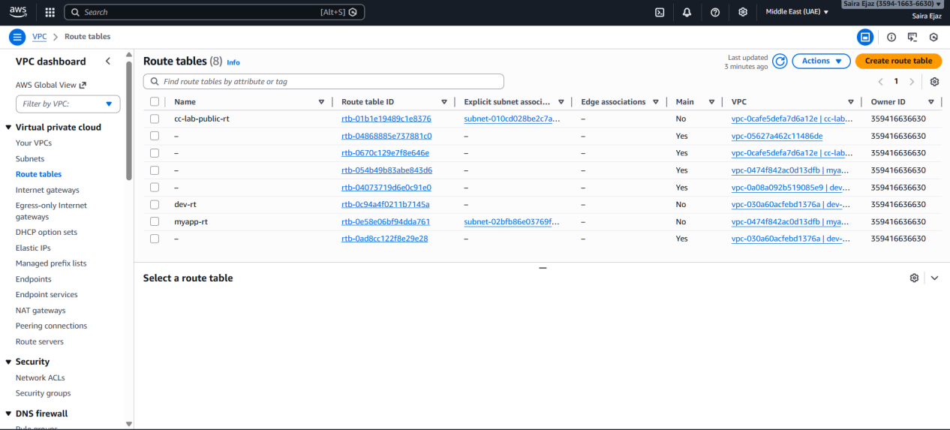
q2_console_sg.png
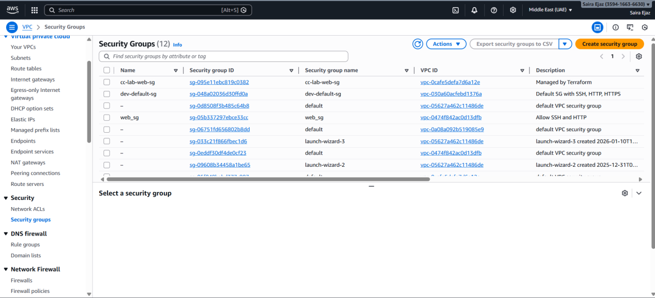
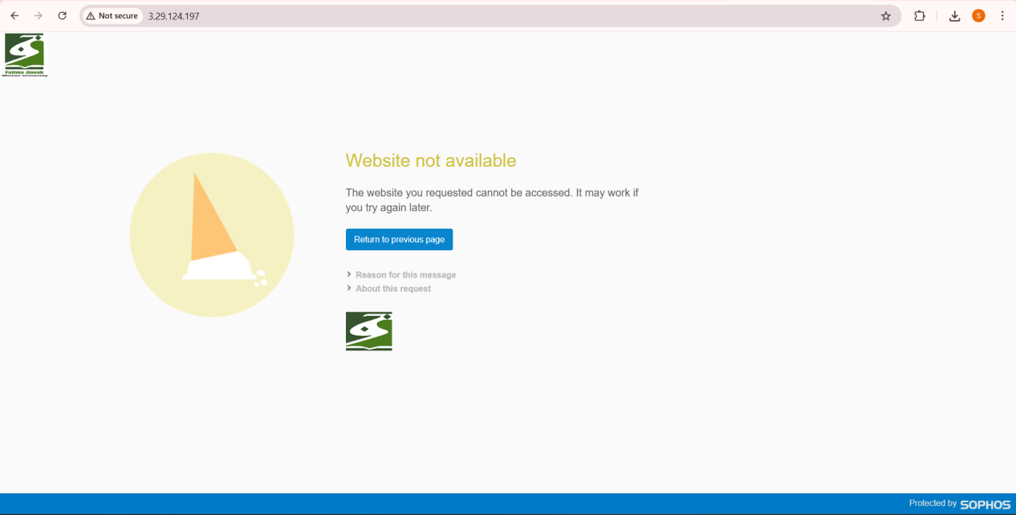
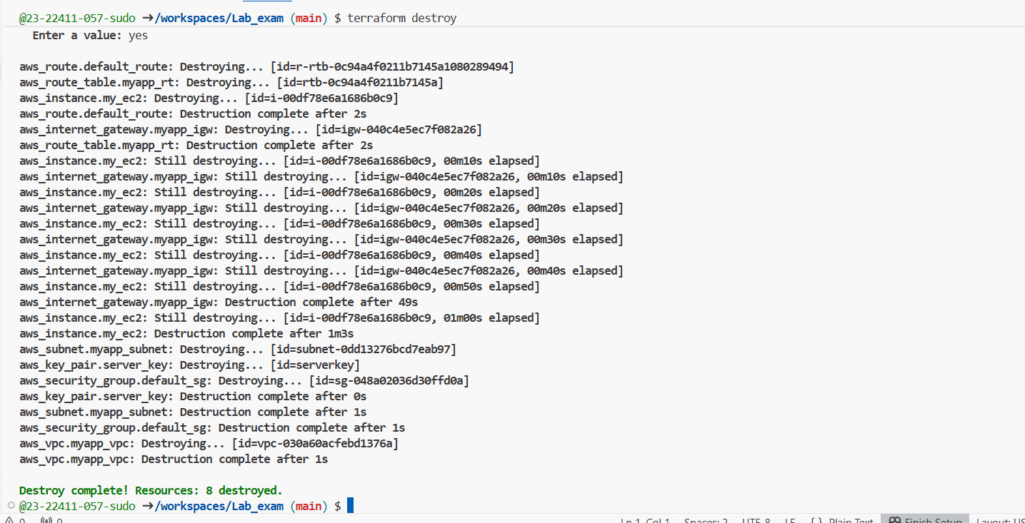

Q3 – Ansible Playbook for EC2 Web Server Using Q2 Instance (10 marks)
q3_hosts.png
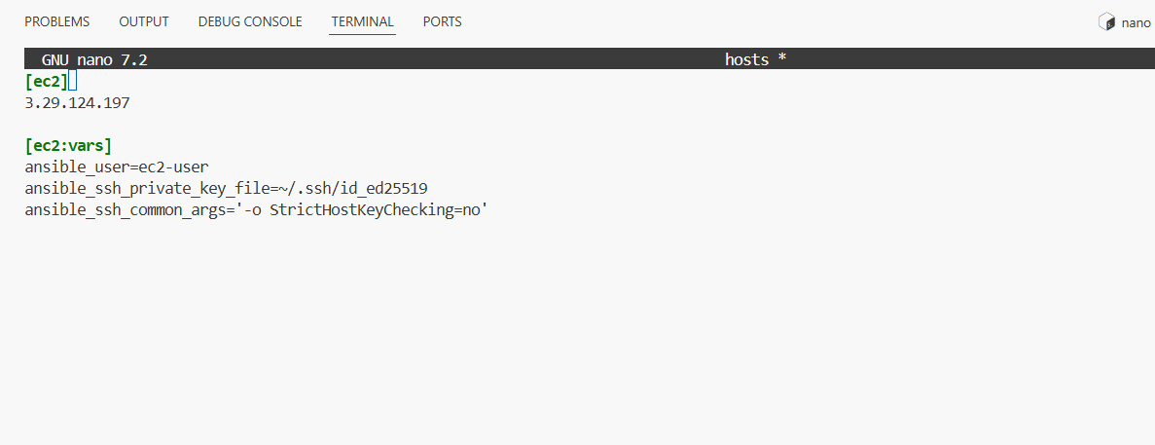
q3_ansible_cfg.png
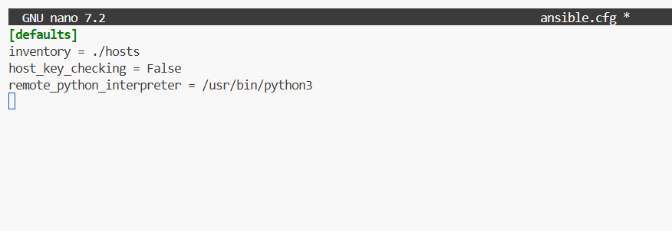
q3_playbook.png
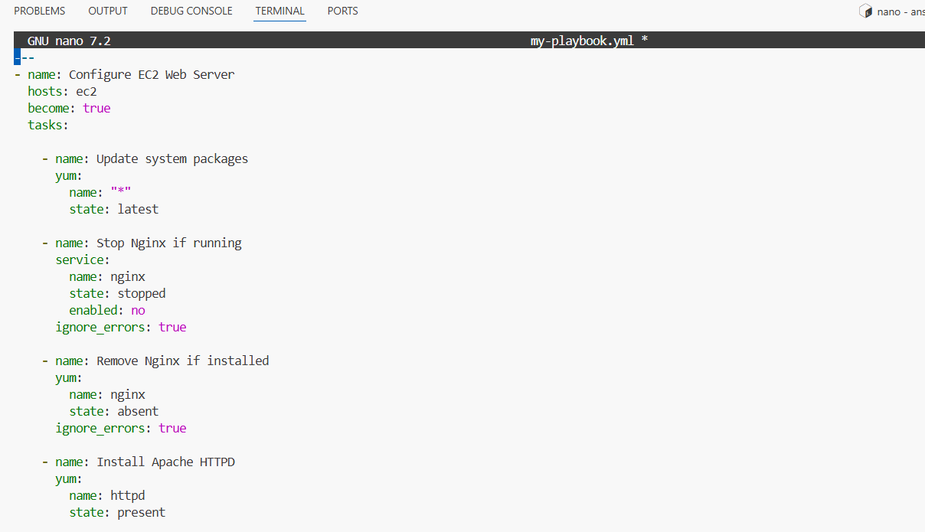

q3_play_run.png
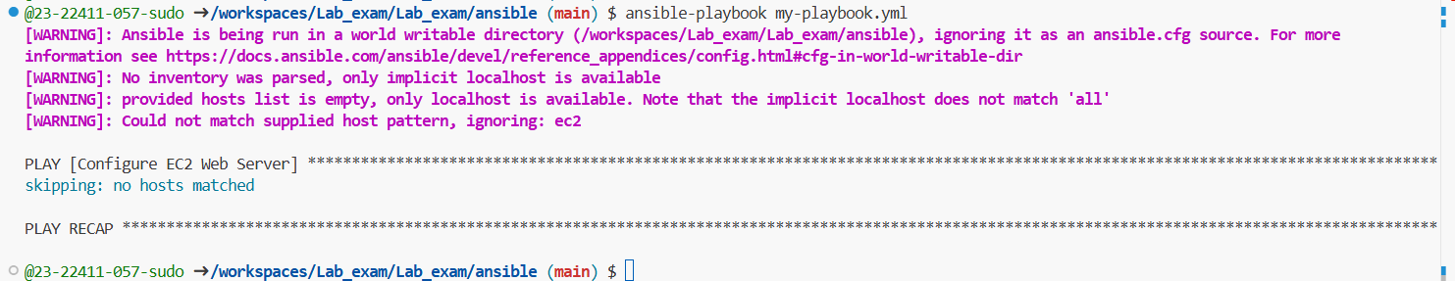
q3_http_browser.png
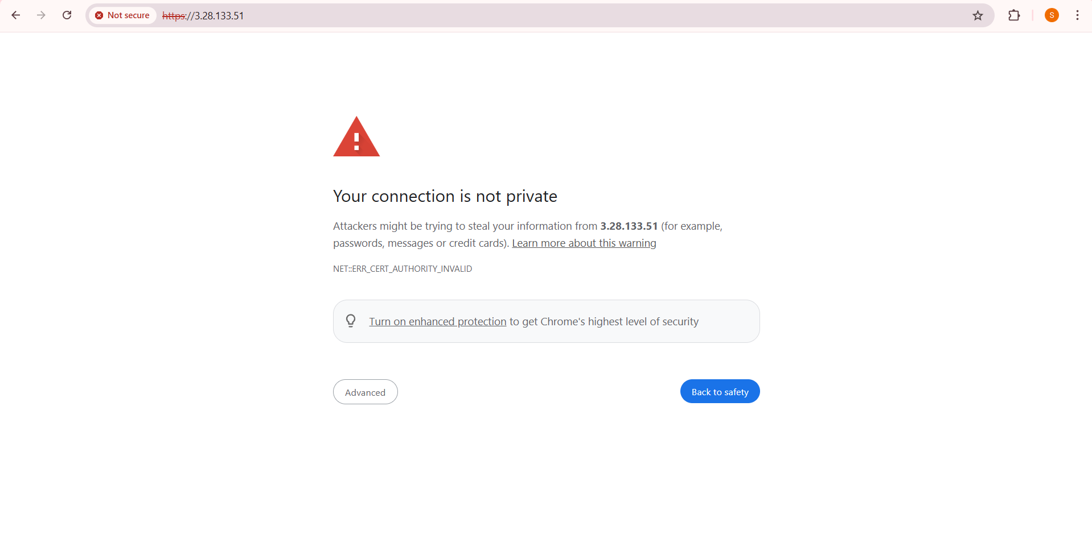
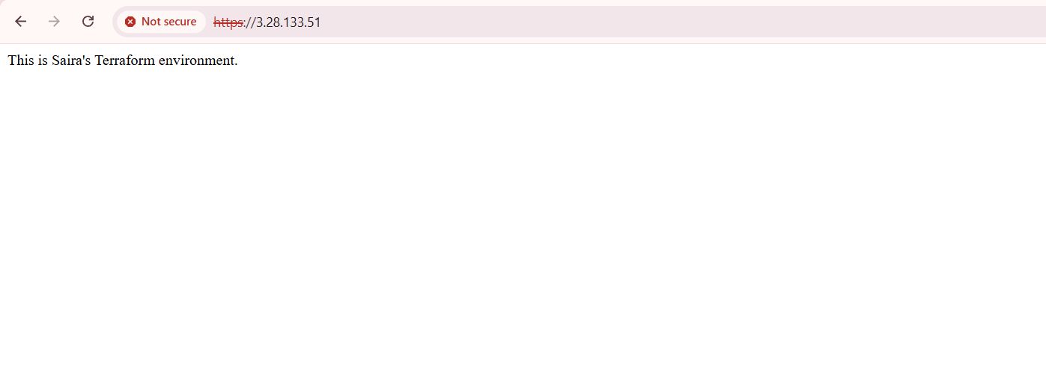
Cleanup:
